OPM3® ProductSuite Entrance Examination

The qualification process for a candidate PMI Certified OPM3 Assessor/Consultant for the first year’s certification has three steps.

The first step is referred to as “Entrance Assessment” and has two elements: the OPM3 ProductSuite Entrance Exam and the Experience Requirement Screening (ERS). All candidates must pass these two elements.

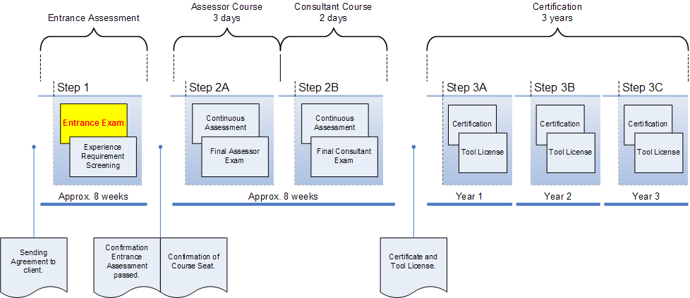

The objective of the Entrance Examination is to assess if the candidate has in-depth knowledge of the OPM3 standard necessary to enter the next step in the OPM3 qualification process. The objective of this document is to provide sufficient information for a candidate PMI Certified OPM3 Assessor/Consultant to prepare for the Entrance Examination.

The candidate will be tested by means of 100 multiple choice questions, each of them having four possible answers. The candidate will be allowed a maximum of 2 hours to complete the questionnaire which can be accessed by the candidate through a web based online application. The candidate will be granted access to the application after having received the confirmation by DNV and a personal login code and password.

Recommendations:

DNV strongly recommends the candidate to prepare for the Entrance Examination by studying all chapters and appendices of the OPM3 Knowledge Foundation version 1 thoroughly and conduct an OPM3 Assessment (preferably a real life one). In order to be able to conduct an OPM3 Assessment the candidate must have access to the Capabilities Directory. The OPM3 version 1 is built on the PMBOK® Guide 2000 Edition.

The Entrance Examination will cover the following Sections and Chapters of the OPM3® Knowledge Foundation:

- Section 0 10 questions
  - Preface
  - Executive Summary
- Section 1; Introduction to OPM3 15 questions
  - Chapter 1; Foundational Concepts
  - Chapter 2; user Overview
- Section 2; Understanding the Model 25 questions
  - Chapter 3; Best Practices
  - Chapter 4; The Organizational Project Management Processes
- Section 3; Using the Model 20 questions
  - Chapter 5; The OPM3 Directories
  - Chapter 6; The OPM3 Cycle
- Section 4; Appendices 30 questions
  - Appendix D; OPM3 Self Assessment
  - Appendix E; Comprehensive Assessment; Detailed Sub-Steps
  - Appendix F; Best Practices Directory
  - Appendix G; Capabilities Directory
  - Appendix H; Improvement Planning Directory
  - Appendix I; Program and Portfolio Management Process Models
  - Glossary

Total: 100 questions

In order to pass the exam, the candidate must answer at least 50% of all questions in each of the above mentioned sections correctly as well have an overall score for the whole exam of at least 67%.

Note: A significant part of the Examination at the end of the OPM3 Assessor course and/or OPM3 Improvement course will also cover the OPM3® Knowledge Foundation version 1.

